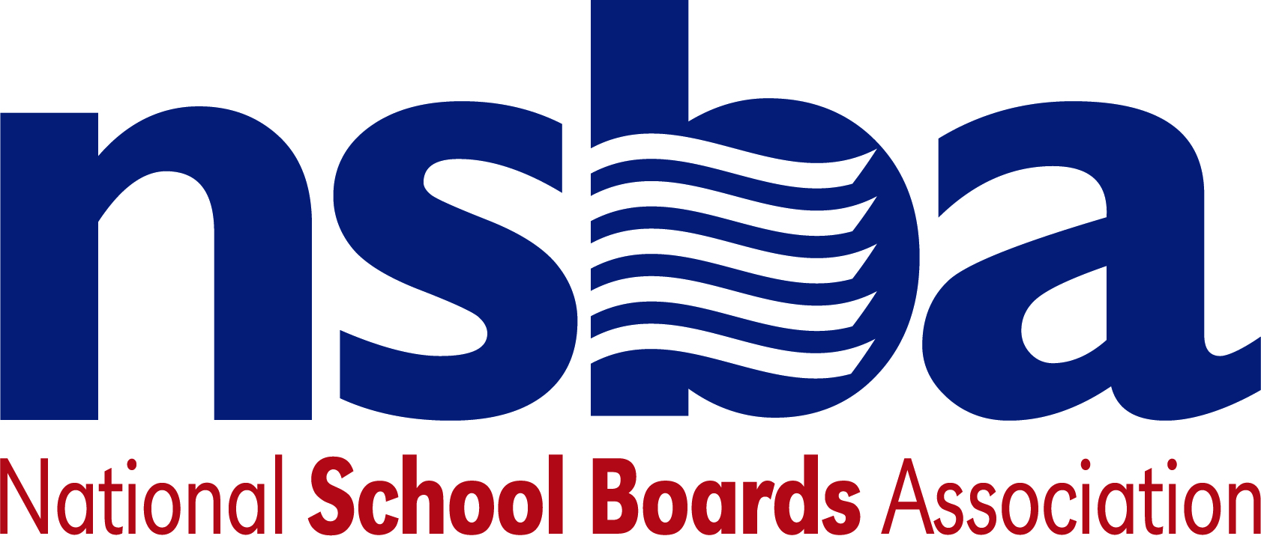

Federal Advocacy & Public Policy Team
October 1, 2021
NSBA Weekly Update
Congressional Update

Government Shutdown Averted
Earlier this week Senate Republicans unanimously voted down short-term funding legislation, known as a continuing resolution (CR), that would extend current funding levels for federal programs, like the Every Student Succeeds Act (ESSA), and avoid a shutdown of federal government operations. The measure, which was passed by the House last week, funds the government and related programs through December 3 and would also have included a suspension of the debt ceiling—a key issue at the heart of Congressional Republican opposition to the legislation. On Thursday, September 30, leaders in the Senate removed the debt ceiling provision from this CR, passed the legislation out of the chamber by a vote of 65-35, and sent it back to the House where lawmakers in the lower chamber quickly approved the measure 254-175. President Biden then signed the legislation into law late Thursday night, averting a shutdown of the federal government.

Lawmakers must still determine full-year funding for FY22, but now have approximately nine additional weeks to find agreement on this issue. At the same time, however, The U.S. Treasury Department anticipates that the agency will run out of borrowing authority to service its current debt obligations by October 18. Failure to suspend or raise the debt ceiling—the total allowable amount of money the federal government is permitted to borrow—would result in a catastrophic default on the nation’s debt. While Democrats have attempted to include a suspension of the debt ceiling in the CR, and have more recently attempted to pass a stand-alone suspension of the debt ceiling on Wednesday, Congressional Republicans have continued to insist that Democrats pass this on their own via the ongoing budget reconciliation process. At present, it remains unclear how lawmakers will ultimately address this issue in days and weeks ahead.

Uncertain Future for Infrastructure and Reconciliation Bills
Late Thursday night, September 30, the lawmakers in the House were expected to take up and vote on the Senate-passed, bipartisan infrastructure bill (formerly known as the Bipartisan Infrastructure Framework or BIF). Continued disagreement between progressives and moderates within the Democratic Party, however, forced leadership to pull this measure from consideration late Thursday evening. Both sides remain at odds over how to pass the BIF—a priority for moderates—along with a wider domestic spending package via the reconciliation process which remains a key priority for progressives. Congressional Democratic leadership are continuing to negotiate internally with their caucus in an effort to collect the necessary support to pass both measures this fall. As these talks continue, NSBA will continue to advocate for the significant infrastructure and connectivity needs of the K-12 community.

House Education Committee Explores School Reopening Efforts
On Wednesday, September 29, the House Education and Labor Committee’s Subcommittee on Early Childhood, Elementary, and Secondary Education held a hearing to learn more about the challenges facing schools as they work to open safely this fall for in-person instruction. The hearing also explored how states and school districts are making use of the funding provided by the American Rescue Plan towards this end. Witnesses included Dr. Jesus F. Jara, Superintendent of Schools in Clark County School District, NV, Denise Forte, Interim Chief Executive Officer of The Education Trust, David Zweig a journalist for The Atlantic and Wired Magazine, along with Dr. Ashish K. Jha, Dean & Professor of Health Services, Policy & Practice at Brown University’s School of Public Health. An archived video of the hearing, along with written testimony from witnesses, can be found here.

Senate HELP Committee Holds School Reopening Hearing
On Thursday, September 30, the Senate Health, Education, Labor, and Pensions (HELP) Committee held a hearing exploring issues related to school reopenings amid the ongoing COVID-19 pandemic. U.S. Secretary of Education Miguel Cardona and Secretary of Health and Human Services (HHS) Xavier Becerra provided testimony to the committee regarding best practices and answered questions from committee members. In particular, Secretary Cardona highlighted the Biden Administration’s ongoing efforts to support K-12 schools safely reopen, including the U.S. Department of Education’s ongoing work to implement and distribute Congressionally approved pandemic aid dollars to school districts. More information on the hearing, including an archived webcast and related testimony, can be found here.

Administration Update

USDA Announces Supply Chain Disruption Funds for Schools
On Wednesday, September 29, the U.S. Department of Agriculture (USDA) announced the availability of new funds to address a range of issues including to support school meal programs. The announcement specifies that up to $1.5 billion will be made available to help K-12 schools respond to and address supply chain issues as they relate to school meal programs. Per a USDA press release, the Department anticipates that these funds will be used for, “[the] procurement of agricultural commodities and enable USDA’s Food and Nutrition Service (FNS) and Agricultural Marketing Service (AMS) to enhance the toolbox for school nutrition professionals working hard to make sure students have reliable access to healthy meals.”

Second Window for Connectivity Funds
On Wednesday, September 29, the Federal Communications Commission (FCC) announced the opening of a second application filing window for the Emergency Connectivity Fund (ECF) program. Created as part of the American Rescue Plan, the ECF Program allows eligible schools and libraries to apply for financial support to purchase connected devices like laptops and tablets, Wi-Fi hotspots, modems, routers, and broadband connectivity to serve unmet needs of students, school staff, and library patrons at home during the COVID-19 pandemic.

This second opportunity to apply for funding will remain open through October 13. Eligible schools, libraries, and consortia will be able to submit request for funding to make eligible purchase between July 1, 2021 and June 30, 2022. More information on how to apply can be found here.

New K-12 Bills
- H.R.5428 — 117th Congress (2021-2022) To require the Secretary of Education, in consultation with the Attorney General and the Secretary of Health and Human Services, to publish an annual report on indicators of school crime and safety that includes data on school shootings, and for other purposes. Sponsor: Rep. Wasserman Schultz, Debbie [D-FL-23]
- H.R.5424 — 117th Congress (2021-2022) To amend the Richard B. Russell National School Lunch Act to eliminate certain requirements under the summer food service program for children, and for other purposes. Sponsor: Rep. Kim, Andy [D-NJ-3]
- H.Res.689 — 117th Congress (2021-2022) Expressing support for the designation of September 2021 as "National Workforce Development Month" and recognizing the necessity of investing in workforce development to support workers and to help employers succeed in a global economy. Sponsor: Rep. Bonamici, Suzanne [D-OR-1]
- H.R.5396 — 117th Congress (2021-2022) To amend title IX of the Education Amendments of 1972 to establish standards of liability for harassment on the basis of sex, and for other purposes. Sponsor: Rep. Dingell, Debbie [D-MI-12]
- H.R.5380 — 117th Congress (2021-2022) Helping Students Plan for College Act of 2021 Sponsor: Rep. Kim, Andy [D-NJ-3]

NSBA Update

NSBA Asks White House for Federal Support to Protect Education Leaders
NSBA sent a letter to President Biden on Wednesday, September 29, asking for federal assistance to stop threats and acts of violence against public schoolchildren, public school board members, and other public school district officials. The letter underscores that local school board members want to hear from parents and community members on important issues and it acknowledges that such feedback is at the heart of good school board governance and promotion of free speech. It also notes, however, that there must be safeguards in place to protect public schools and dedicated education leaders as they do their jobs. “As the threats grow and news of extremist hate organizations showing up at school board meetings is being reported, this is a critical time for a proactive approach to deal with this difficult issue,” the letter argues. Read the press release and the letter at https://nsba.org/News/2021/federal-assistance-letter.

No CSALS meeting Monday.

