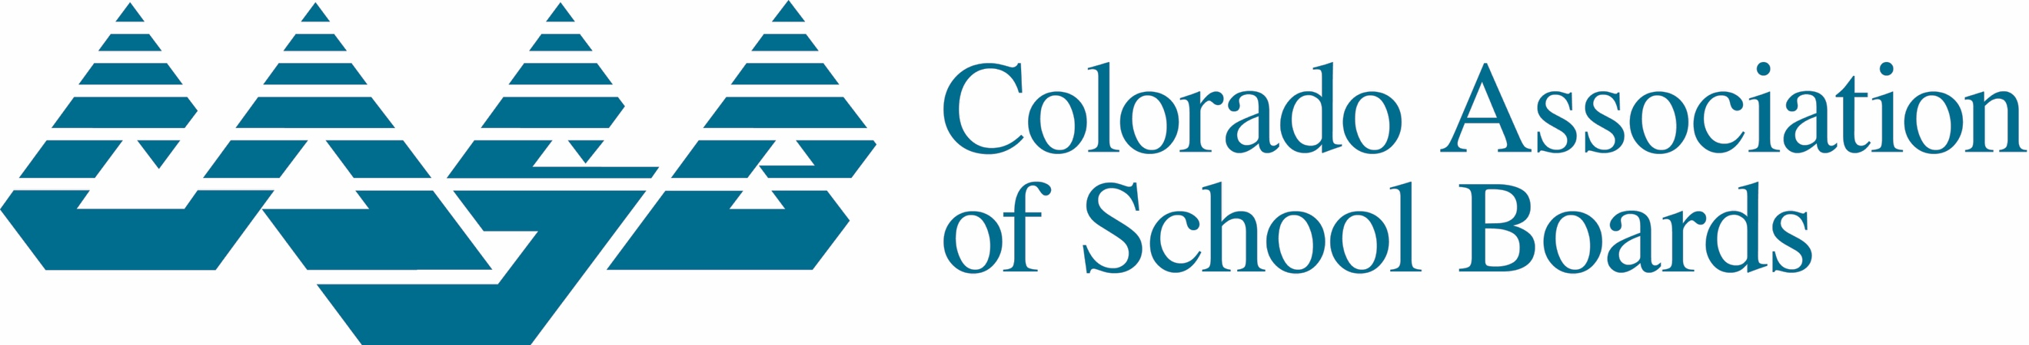

2253 S. Oneida St., Ste. 300
Denver, CO 80224
303-832-1000
Web Site: www.casb.org

Continuing Education Clock Hour Credit Form

Colorado Association of School Boards
81st Annual Convention, December 2 – 4, 2021

Use this form to verify your attendance at the various professional development sessions during the event. It is the individual’s responsibility to maintain accurate records for compliance with certification regulations. Please print and use pen only.

I. Participant Information
Legal Name (First, Middle, Last):

Email Address:

Cell Phone: ______________________________________________________________________________
District:

II. Breakout Session(s) Information (Include an additional page for sessions if necessary)
Title of Breakout Session: ______________________________________________________________________________

Date and Time of Session: _____________________________ Clock Hours: ________________

Title of Breakout Session: ______________________________________________________________________________

Date and Time of Session: _____________________________ Clock Hours: ________________

Title of Breakout Session: ______________________________________________________________________________

Date and Time of Session: _____________________________ Clock Hours: ________________

Title of Breakout Session: ______________________________________________________________________________

Date and Time of Session: _____________________________ Clock Hours: ________________

Title of Breakout Session: ______________________________________________________________________________

Date and Time of Session: _____________________________ Clock Hours: ________________

III. Participant Affidavit:

I, ________________________________________________________________affirm that I

attended _____________ clock hours for actual attendance at this event.

Signature: ___________________________________________
Date: _______________________________________________

Mail (USPS) completed form to: Leslie Bogar, Director of Professional Learning, Colorado Association of School Boards, 2253. S. Oneida St., Ste. 300, Denver, CO 80224
Certificate of event clock hours will be emailed within 20 business days of receipt.

