Candidate Affidavit

Colorado High School Activities Association
(CHSAA) Legislative Council

School Board Representative

This affidavit shall certify that I, ___________________________________, a member of the
__________________________ Board of Education, am a candidate for a school board representative seat on the CHSAA Legislative Council. I further certify that the afore- mentioned Board of Education is a member in good standing of CASB and that at least one school in our district is a member in good standing with CHSAA.

This certifies that I am a candidate for one of the following seats:

___ Representative A CASB Regions 1 and 4 (1-year term, ending Dec. 2024)
___ Representative E CASB Regions 9, 11, and 12 (1-year term, ending Dec. 2024)

Signature of candidate: ___________________________________ Date: __________________

Address: ______________________________________________________________
Phone Number: ________________________________

Signature of Board President: __________________________________ Date: __________________
(or other authorized officer of the board)

Please return a completed affidavit to CASB and include a statement of 150 words or less about your local board service and/or why you want to serve on the CHSAA Legislative Council. Statements should be an electronic submission in Word format and will be included in materials emailed to the CASB membership. CASB reserves the right to edit entries for length.

Candidate deadline:

- Wednesday, February 7, 2024 (4:00 p.m.)

Return affidavit and statement to:
Tracy DeMeo
tdemeo@casb.org

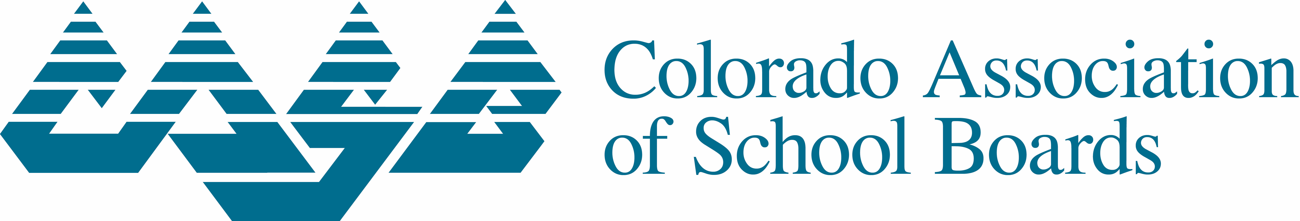
2253 S. Oneida Street, Suite 300, Denver, CO 80224
Phone: (303) 832-1000

